July 8th, 2009

Valentino Danchev
Project Director
Mayan Palace

Puerto Peñasco

Re: Rocky Point Airlines

Valentino Danchev,

The following will serve as our formal introduction of Rocky Point Airlines to the Mayan Palace Group. After weeks of review, and routing studies, including several flights in the region, we are prepared to commence operations of our service in the Sonora and Arizona regions.

Given the unique position of the Puerto Peñasco area for current and future growth, and the absolute lack of air service, we believe our company is poised to not only dominate this market, but to develop with it in future growth.

I. Equipment

Rocky Point Airlines, a wholly owned Mexican Corporation dully registered with the Secretaria de Hacienda and Credito Public is commencing charter and scenic flight operations in Sonora and Arizona. Our company starts with a Cessna 402A a 9 seat aircraft registered with a XB tail number, aero taxi subchapter with the Direccion General de Aeronautica Civil (DGCA, Mexican FAA)

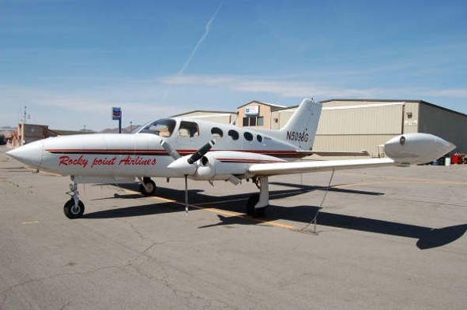

Our operations will be two tiered, with scheduled scenic flights over Puerto Peñasco, and charter routes between Mesa, Arizona, and Puerto Peñasco/San Carlos, Sonora, as well as between Puerto Penasco and Los Cabos, Baja California.. The central objective of our charter routes are to offer our customer base the choice of direct-to routing by air reducing the overland travel with its commensurate risks and time delay. Given the large distances to travel to get to Puerto Peñasco, San Carlos and Los Cabos, our service offers a unique, safe and fast option to the traveling public.
Ground transportation to/from the Mayan Palace Jolla de Cortez would be provided to our clients to shuttle them from Puerto Peñasco to the airport strip.

The marketing angle for Mayan Palace would include very economical air transportation (less than half the price of any competition) making the Mayan Palace the only resort in Latin America with such an affordable amenity.

II. Routes

The following is a point to point run down of charter operations offered by Rocky Point Airlines in the Arizona & Sonora regions. Given the limited or non-existent air routes between these two states, Rocky Point Airlines is inaugurating point to point charter services between the following cities with Mayan promotional discounts and standard fares reflected:

In addition to the international traffic to Puerto Peñasco from San Diego, Phoenix & Tucson Areas, our service would include inter-group property travel, such as from Mayan Palace facilities in Cabo San Lucas, Mazatlan, Nuevo Vallarta & Puerto Vallarta. Acapulco & Riviera Maya would not be practical due to the distances involved. Below the distances and times to transfer guests between facilities

Mayan Palace Inter Facility Traffic

Property Distance Time

Mazatlan to Peñasco 589 Nautical Miles 2 hours 45 minutes
Vallarta to Mazatlan 182 Nautical Miles 45 minutes
Vallarta to Peñasco 771 Nautical Miles 3 hours 35 minutes
Penasco to Los Cabos 526 Nautical Miles 2 hours 45 minutes

Domestic

Peñasco to San Carlos 230 Nautical Miles 1 hour 15 minutes
Peñasco to Hermosillo 177 Nautical Miles 0 hour 45 minutes
Peñasco to San Felipe 62 Nautical Miles 0 hour 25 minutes
Peñasco to Loreto 338 Nautical Miles 1 hours 45 minutes
Peñasco to Los Cabos 526 Nautical Miles 2 hours 45 minutes

International

Peñasco to Phoenix 149 Nautical Miles 0 hour 45 minutes
Peñasco to Tucson 134 Nautical Miles 0 hour 40 minutes
Peñasco to San Diego 209 Nautical Miles 1 hour 05 minutes
Peñasco to Las Vegas 295 Nautical Miles 1 hours 30 minutes

Initial Routing
The longer routes would be mitigated by the de facto scenic tour our passengers would enjoy, such as Bahia de Banderas, San Carlos & Bahia de Kino to mention a few. Further, given the very limited Hermosillo/Mexicali commercial routes which must connect in Monterrey or Mexico City and require entire days trips, our service offers direct to convenience without the hassle of airport commercial connections.
- 287 NM 1 hour 20 minutes Vallarta-Cabos
- 187 NM 50 minutes Cabos-Mazatlan
- 157 nm 45 min Mazatlan-Vallarta

Inter Facility Routing – Pacific

III. Fixed Bases

Rocky Point Airlines counts with a Fixed Base Operation (FBO) in the following cities:

Domestic Base:

- Puerto Peñasco, Sonora, Sea of Cortez International Airport. Air conditioned, customer parking and free shuttle bus
- Rocky Point Airlines desk at Gen Jose Maria Yanez/Guaymas International Airport. Air conditioned and customer parking.

Foreign Bases:

- Arizona Aviation located at 4388 East Falcon Field Drive, Mesa Arizona at Falcon Field, Indent KFFZ. Crew and Passenger Lounge Air conditioned, customer parking.

IV. Synergies

Given the total lack on native commercial air operations in the Peñasco region, Rocky Point Airlines would be filling a crucial gap hitherto absent in this market. In addition to the obvious traffic to/from the Mayan Palace to commercial hubs in the US and Mexico, our aircraft is available for charter with VFR & IFR flight rules, day or night. This operation would in effect give the Mayan Palace Group an Air Transportation Arm based in Puerto Peñasco.

V. Pricing

The following fares are based on commencing operations by the 15th of July 2009 and the promotional segment would last until the end of the month. Further route fares are available and will be submitted in our Fare Schedule published on a quarterly basis to take into account fuel price and fiscal taxing oscillations.
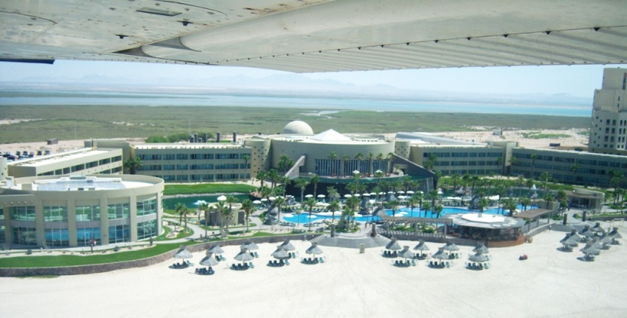

A. Fares Based on Investment by Mayan Palace in Rocky Point Airlines.

Cities Travel Time Price per Plane + Per Seat

Mesa to Puerto Peñasco 57 minutes $350.00 USD $150.00 USD
Mesa to San Carlos 2 hours 30 minutes $550.00 USD $150.00 USD
Puerto Peñasco San Carlos 1 hour 45 minutes $450.00 USD $150.00 USD
Penasco to Los Cabos 2 hours 45 minutes $500.00 USD $250.00 USD
Peñasco Scenic Tour* 30 minutes $ 35.00 USD
Mazatlan to Peñasco 2 hours 45 minutes $600.00 USD $250.00 USD
Vallarta to Mazatlan 45 minutes $250.00 USD $150.00 USD
Vallarta to Peñasco 3 hours 35 minutes $800.00 USD $250.00 USD

B.- Fares Based on Non-Investment by Mayan Palace in Rocky Point Airlines.

Mesa to Puerto Peñasco 57 minutes $500.00 USD $250.00 USD
Mesa to San Carlos 2 hours 30 minutes $700.00 USD $250.00 USD
Puerto Peñasco San Carlos 1 hour 45 minutes $600.00 USD $250.00 USD
Peñasco to Los Cabos 2 hours 45 minutes $800.00 USD $250.00 USD
Peñasco Scenic Tour* 30 minutes $ 45.00 USD
Mazatlan to Peñasco 2 hours 45 minutes $800.00 USD $250.00 USD
Vallarta to Mazatlan 45 minutes $350.00 USD $150.00 USD
Vallarta to Peñasco 3 hours 35 minutes $900.00 USD $250.00 USD

*Scenic tour includes travel to El Pinacate Volcano Field, and overflight La Choya to Mayan Palace via beach.

VI. Legal Environment

The sole authority governing air operations in Mexico is the Direccion General de Aeronautica Civil (DGCA) which is analogous to the American FAA. Our aircraft is owned and operated by Rocky Point Airlines, S.R.L. and registered with DGCA as a Private XB registry, with Aero taxi Subchapter. Additionally, we are registered with the Secretaria de Hacienda y Credito Publico (SHCP), analogous to the American IRS, as a Sociedad de Riesgo Limitado, similar to an American Limited Liability Company (L.L.C.). Further, we are registering the airline with the International Civil Aviation Organization (ICAO) in order to obtain our airline code. With such code, we can apply for and enter the Major Airlines code sharing and reservation system, permitting us to publish our fares and make connections with the various regional hubs to facilitate inter-airline connections for our passengers.

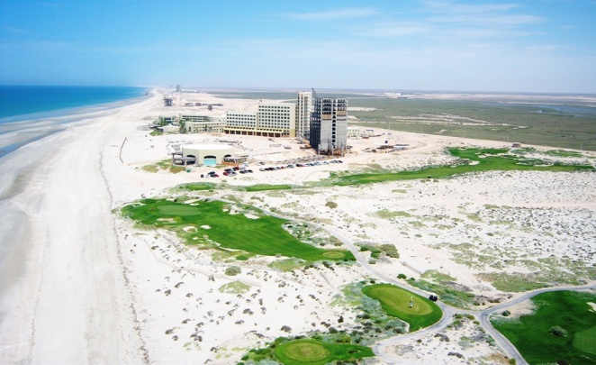

VII. Conclusion

The current air routes offered by our competition are non-existent. Most operators are straddled with operating much more expensive equipment, with the associated costs of maintenance and supply. Rocky Point Airlines has chosen as our principal platform the Cessna 402-B, a more versatile aircraft, which although limited in size, can offer quicker turn around times, as well as cargo areas that allow for customers to bring their fishing rods.
The services we offer allow for quick scheduling and on-site arrivals to Mesa and is compliant to Customs and Border Protection (CPB) eApis (electronic Advance Passenger Information System) requirements. Rocky Point Airlines is registered with CBP eApis program with our aircraft and crew, requiring only that we add passenger manifest 60 minutes prior to cross border penetrations. Currently we have applied for an Over flight Exemption Permit allowing us to fly Peñasco or San Carlos direct to Mesa, Arizona. Until such a permit is issued, we will be clearing customs in Nogales, Arizona which is a stop of no more than 15 minutes. As our passenger manifest will have already been submitted prior to flight, and screened by CPB, the stop in Nogales is purely technical.
The Promotional and Standard Fares reflects under market pricing for said routes. Not only will we be offering a service that currently does not exist, but we are doing so in a more accessible way in terms of scheduling, pricing and amenities offered to our clientele.
We at Rocky Point Airlines are looking forward to making adjustments to your transportation needs and submit a concise schedule for times, cities and pricing you may share with your clientele.

Best Regards,
Capt. Sherman Smith
Capt. Daniel Kane
Rocky Point Airlines

